Atal Tinkering Lab: Report
In an endeavor to inculcate and develop scientific temperament in the young learners of today, DAV Public School, East of Loni Road proudly set its steps into the noble mission of knowledge enhancement by the inauguration of the Atal Tinkering Lab on 30th April, 2019
With a vision to cultivate one million child innovators in India, Atal Innovation Mission by NITI Aayog and Government of India envisaged a novel programme - establishment of Atal Tinkering Laboratories in schools across the country.
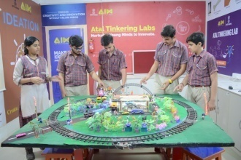
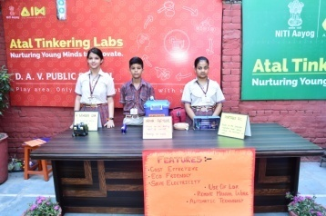
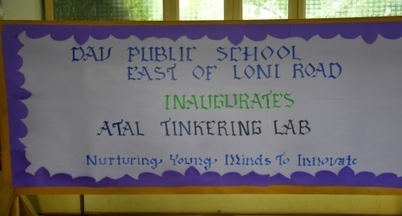

The ATL Lab was inaugurated by Dr. N.K Uberoi[Vice President DAVCMC & Vice Chairman of the school ], Ms. P. Lata Tara , Directorate of Education and Shri Nanak Chand [Manager of the School].
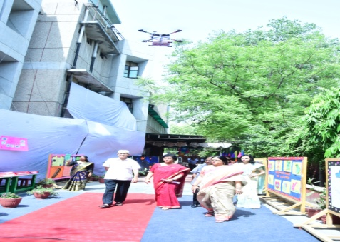
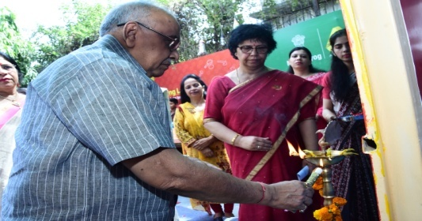
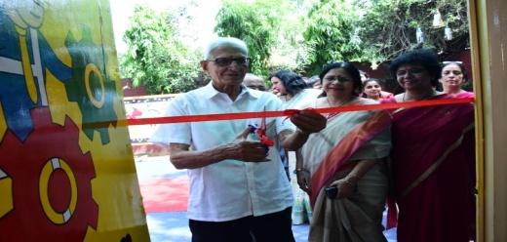

The programme commenced with the lightening of lamp, followed by exuberant floral welcome by drones. Madam Principal welcomed the guest of the day and presented a brief report of school activities which was followed by models of our students. Students presented innovative and futuristic models of Automatic Railway Barrier System, Portable ECG, Automated Irrigation System , Automatic street lightning, skimmer , obstacle Avoider, Home automation and Jet joy. Ms.P.Latatara in her address, emphasized the objective of ATL Mission as well as value system along with joyful learning.

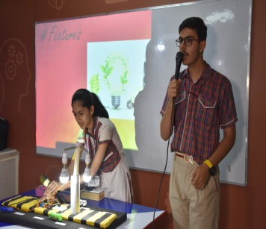
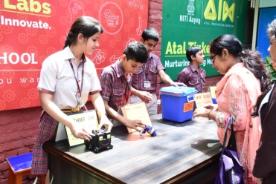
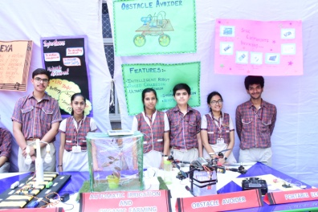
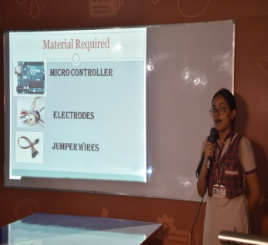

Our guest of the day Dr. N.K Uberoi appreciated the efforts of the staff members and suggested that the environment for joyful learning be provided to the students. He congratulated the school for the setup of ATL Lab, NITI Aayog Project. Meritorious students were awarded by the guest followed by vote of thanks by our Manager Mr. Nanak Chand.
